**RDS-Backup&Recovery**

Amazon RDS includes features for automating database backups. Amazon RDS creates a storage volume snapshot of your database instance, backing up the entire DB instance, not individual databases only. Using Amazon RDS, you can establish a backup window for automated backups, create database instance snapshots, and share and copy snapshots across Regions and accounts.

RDS provides managed instance backups with transaction logs to enable point-in-time recovery. Users pick a retention period and restore databases to any time during that period. They also can manually take snapshots of instances that remain until they are manually deleted.

RDS lets users specify the time and duration of the backup processes. They also can choose how long to retain backups and snapshots.

**LAB:**

Create a database

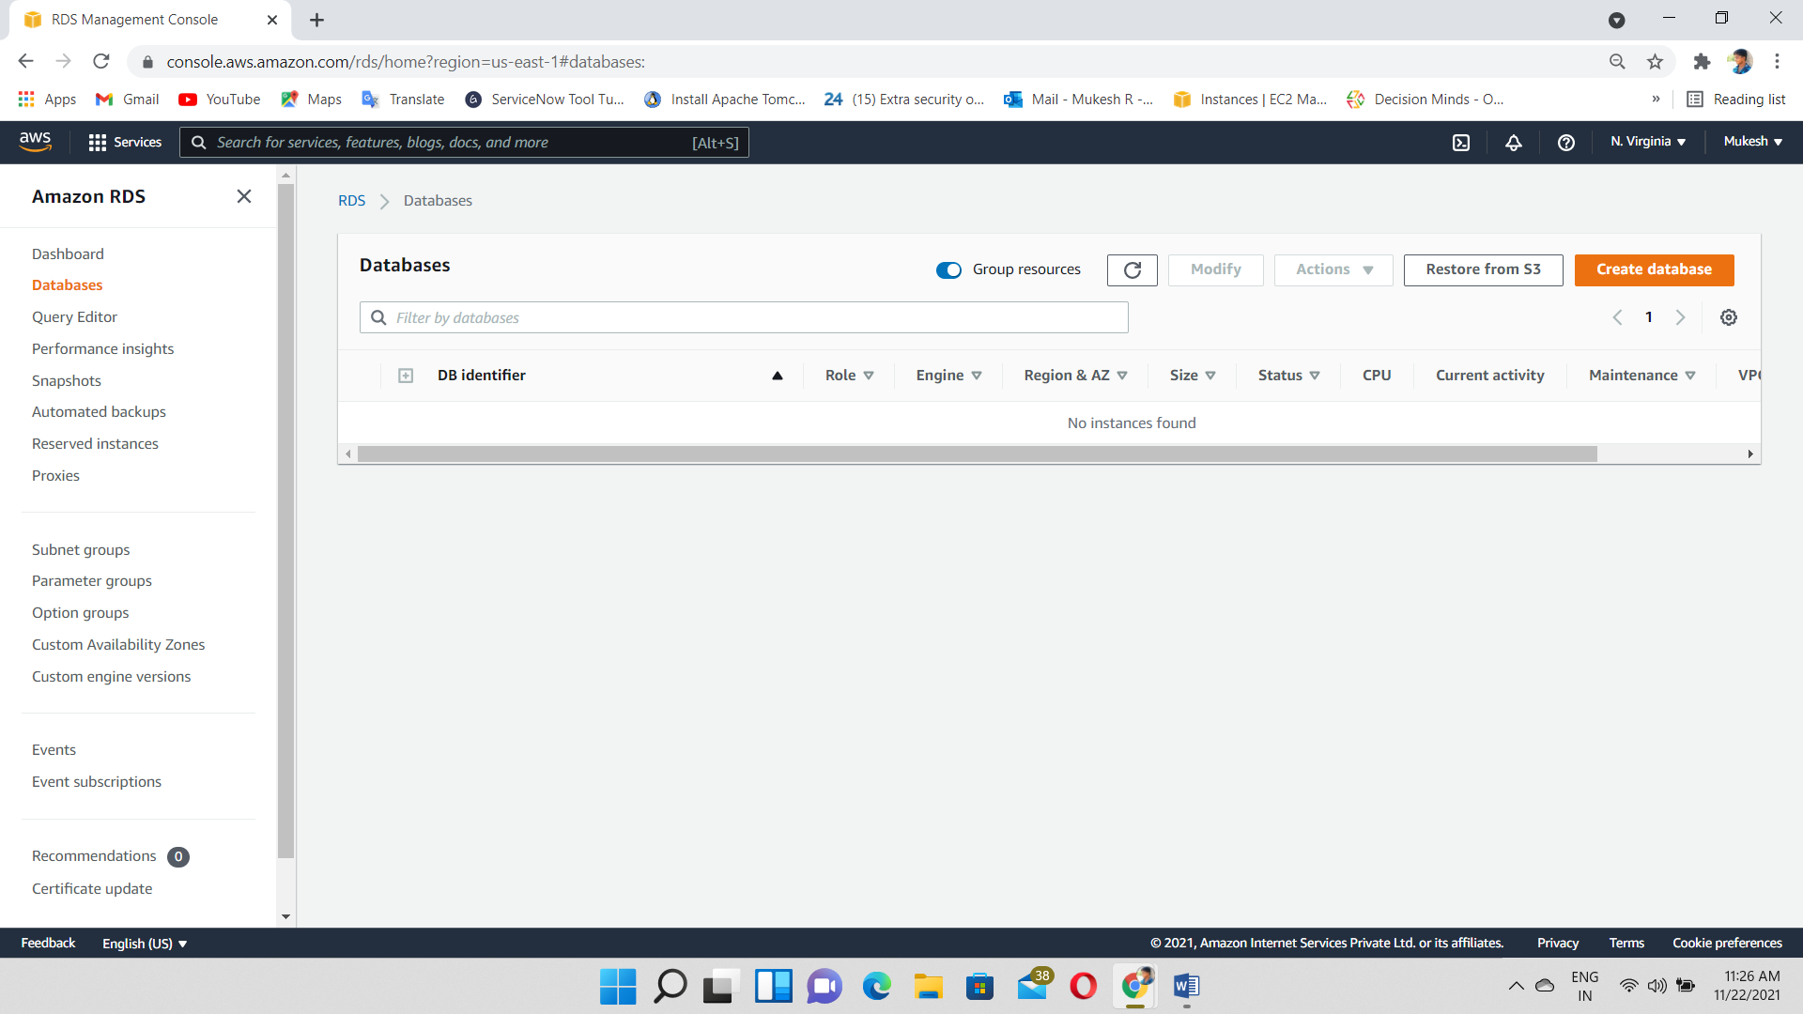

Select the MySQL engine type

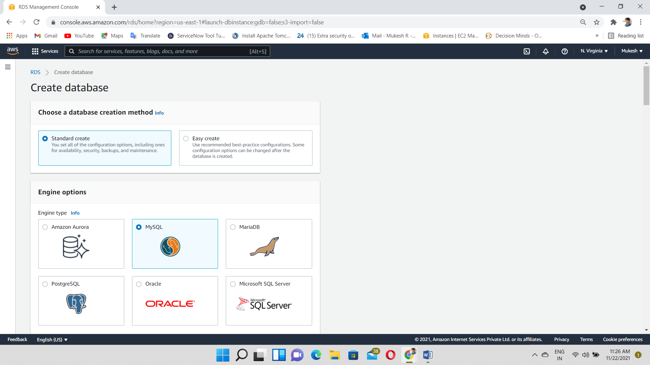

Select the SQL version 5.7.22 and Choose Free tier

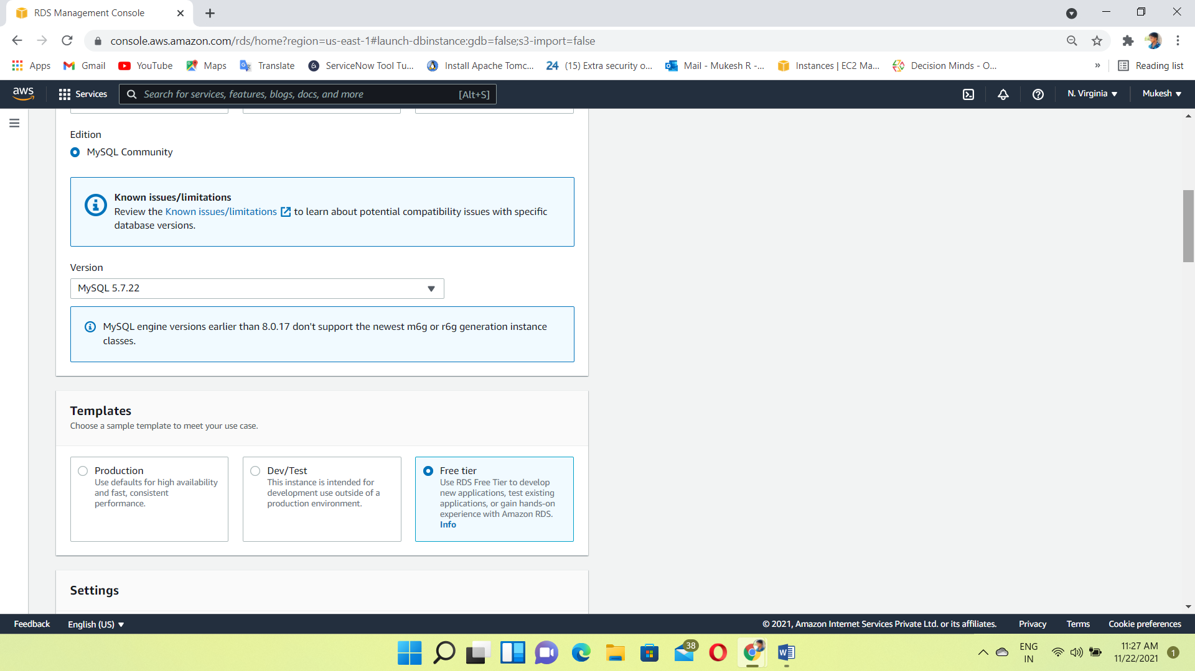

Giving to the DB Instance name & Username, Password we want

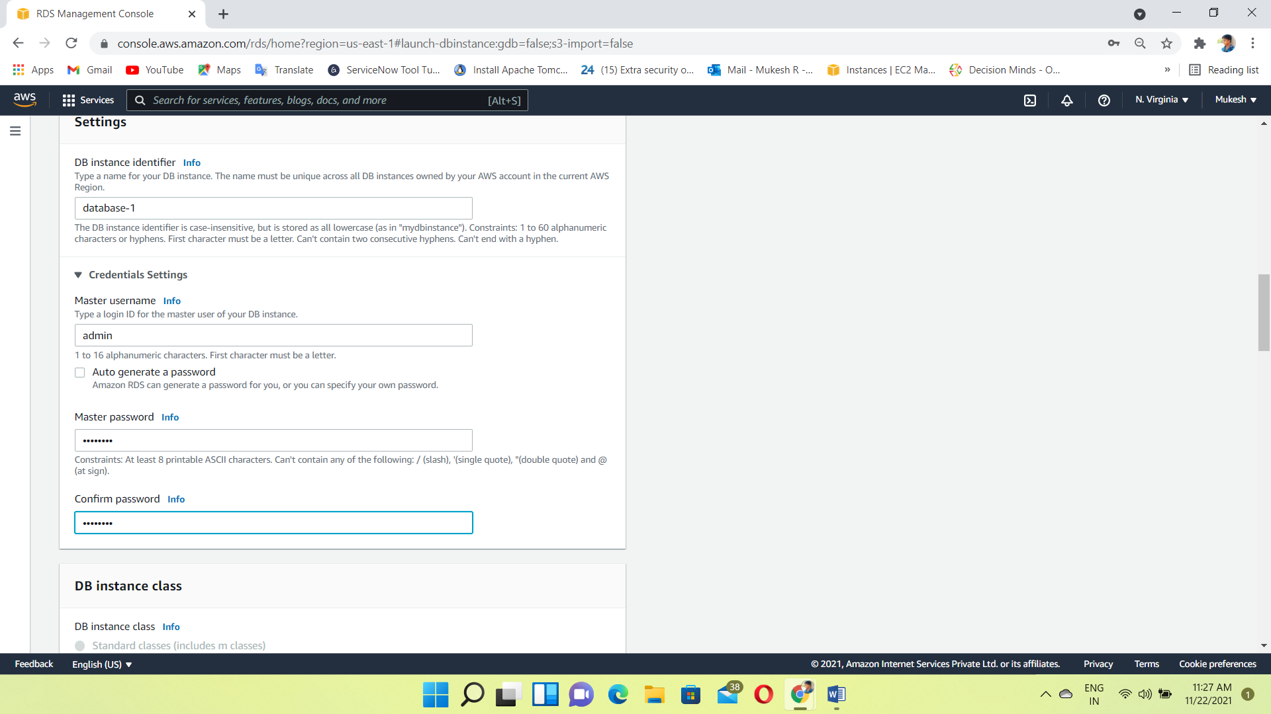

Allocated the storage we want- minimum 20GiB, Maximum 16 TiB

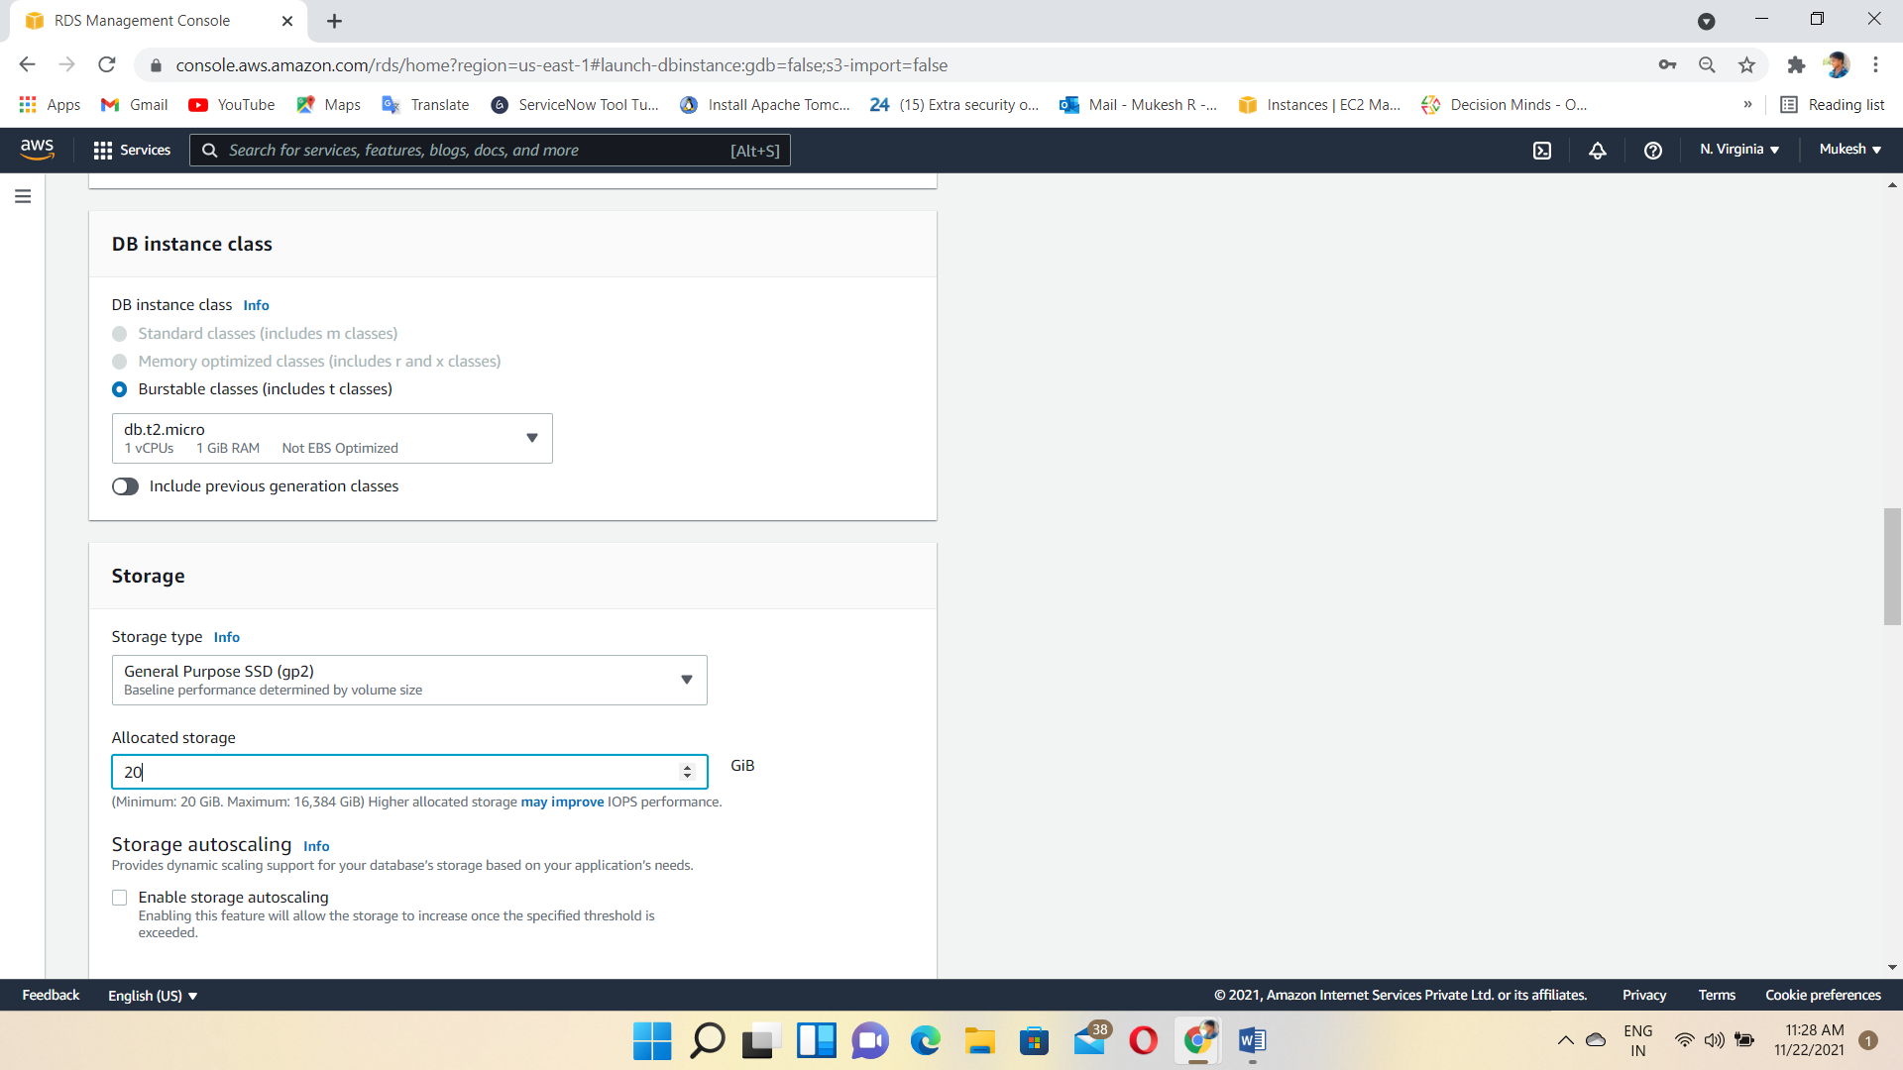

Choose the DB instance details like VPC, Subnet Group, Security Group

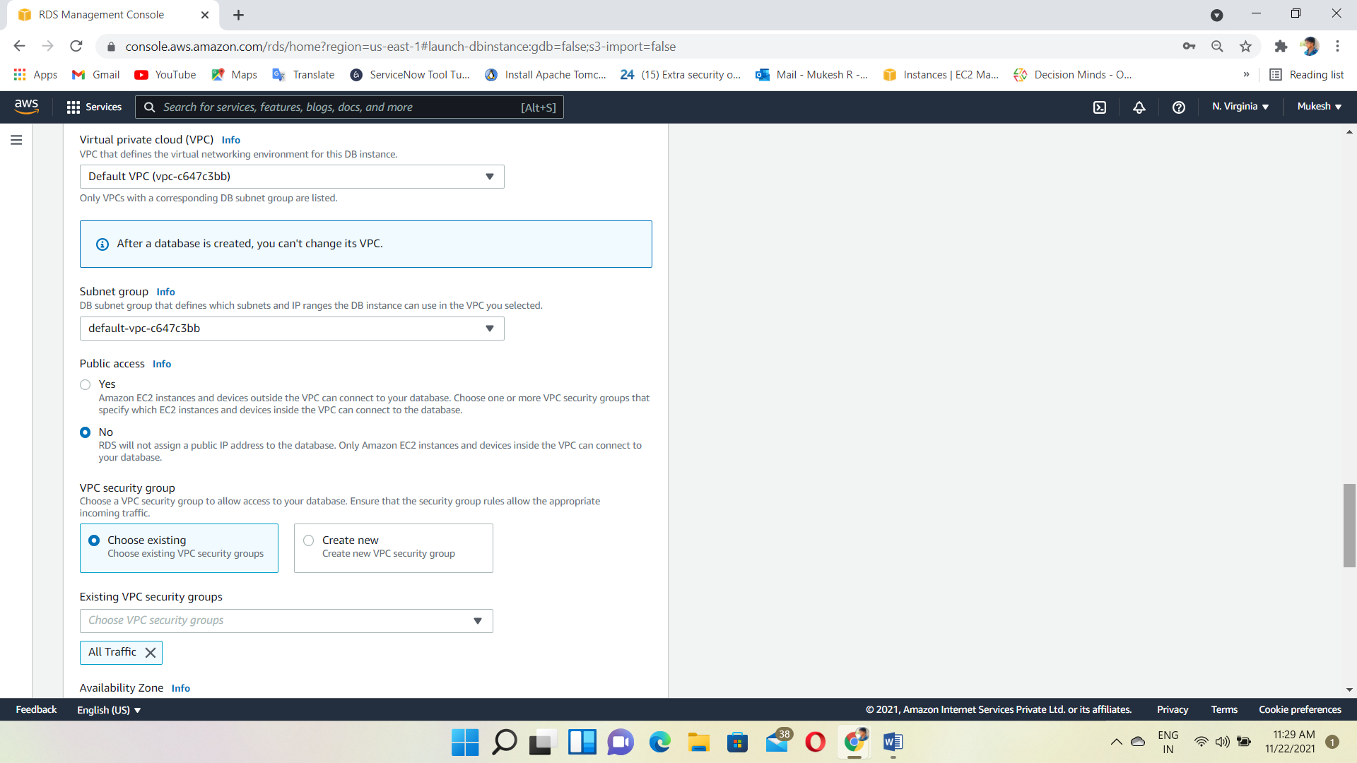

Create a Database

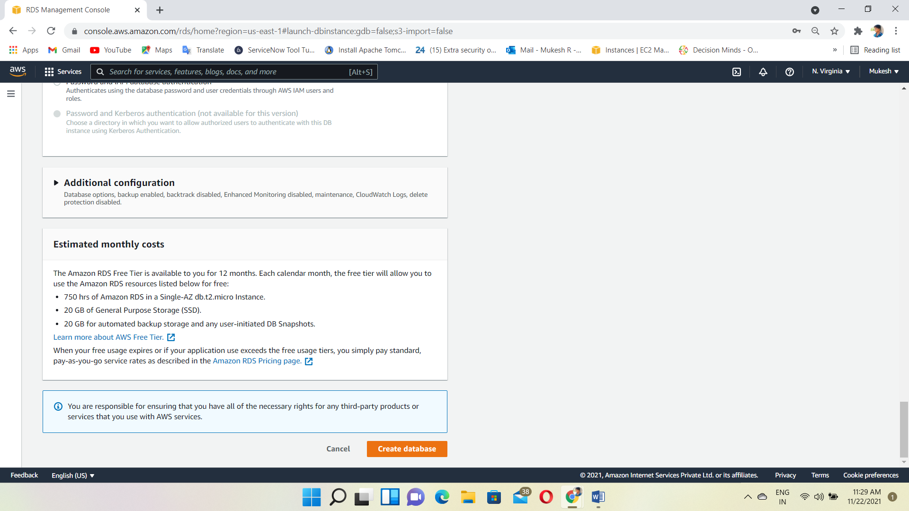

Go to Ec2 Dashboard and create one instance for frontend server

Choose a RHEL8 AMI

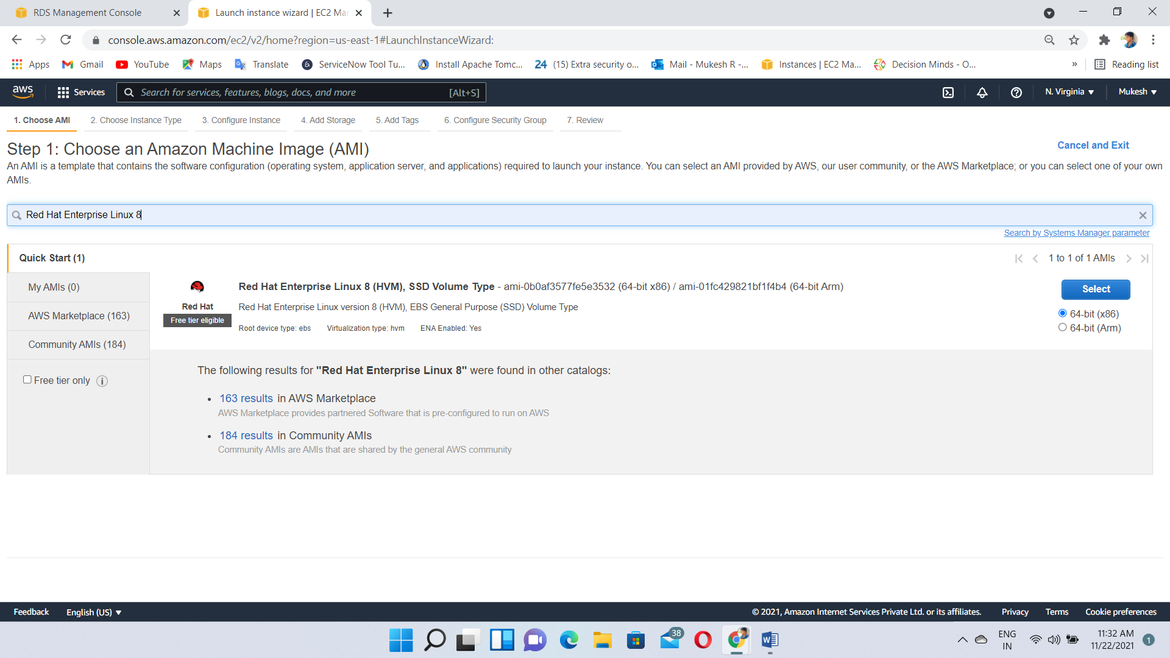

RHEL8 instance Created and Status also running

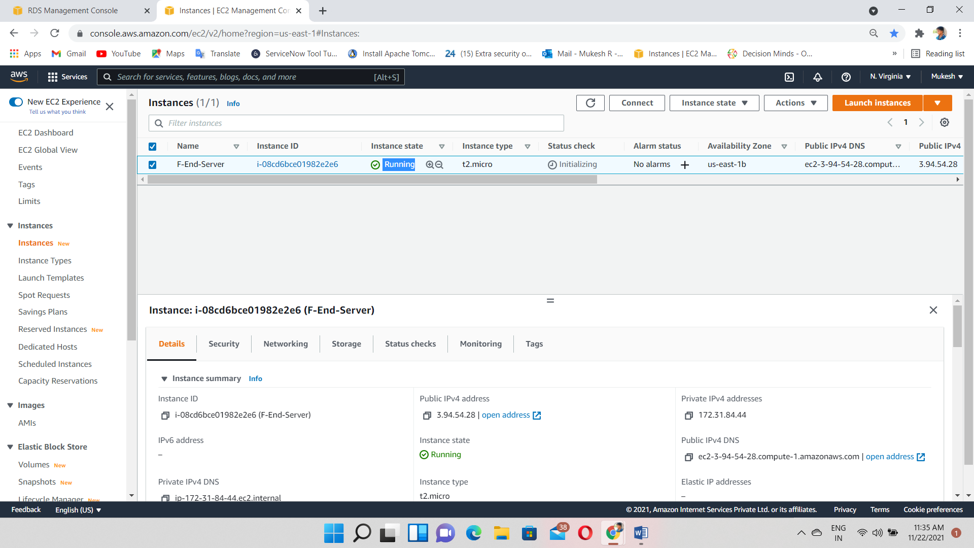

Database also created & check the status Available or Not

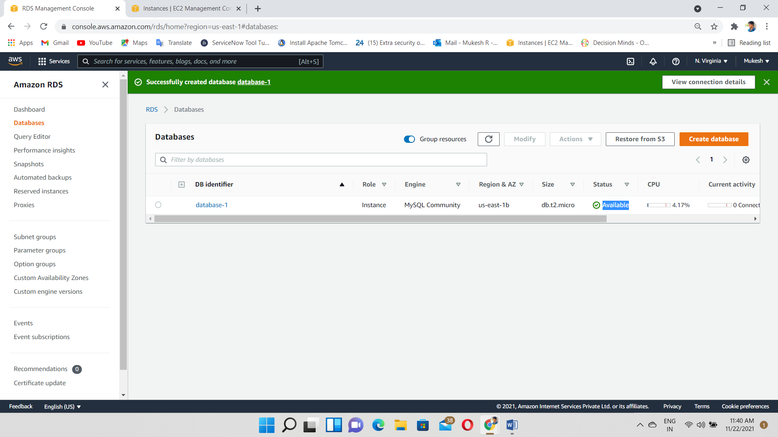

Login to the RHEL8 instance using putty

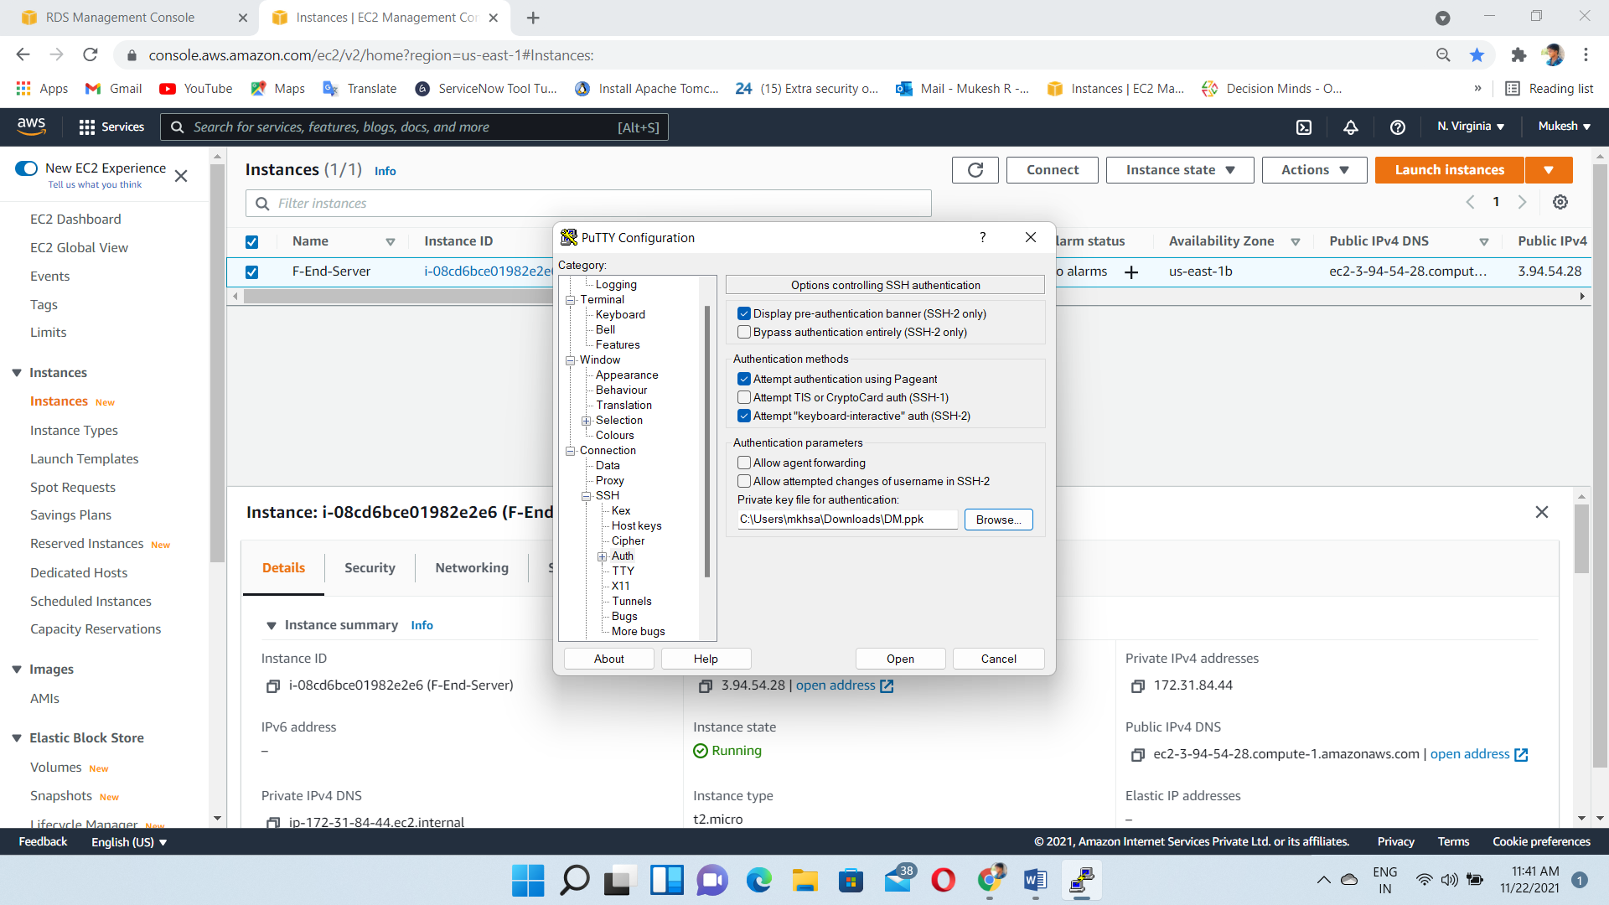

Install MySQL using –> yum –y install mysql

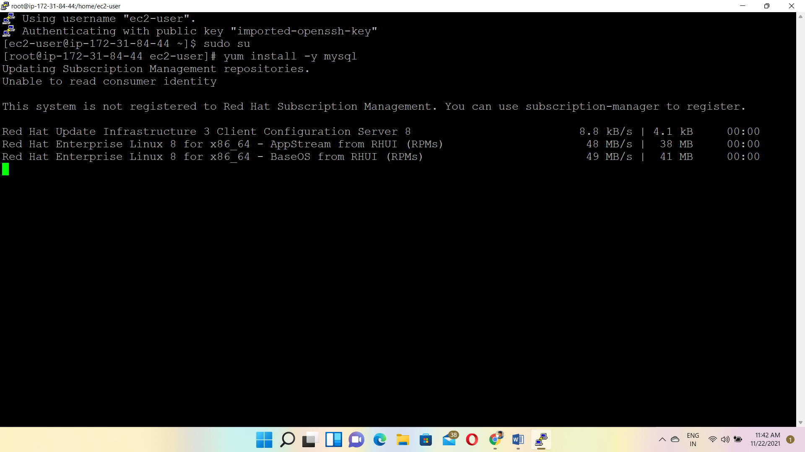

Installation Completed

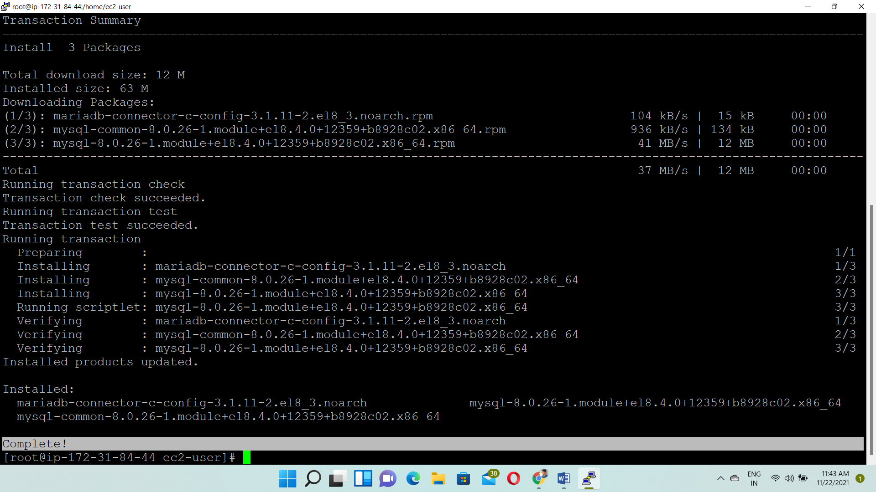

Enter the MySQL database endpoint, Port number, User Name & Password

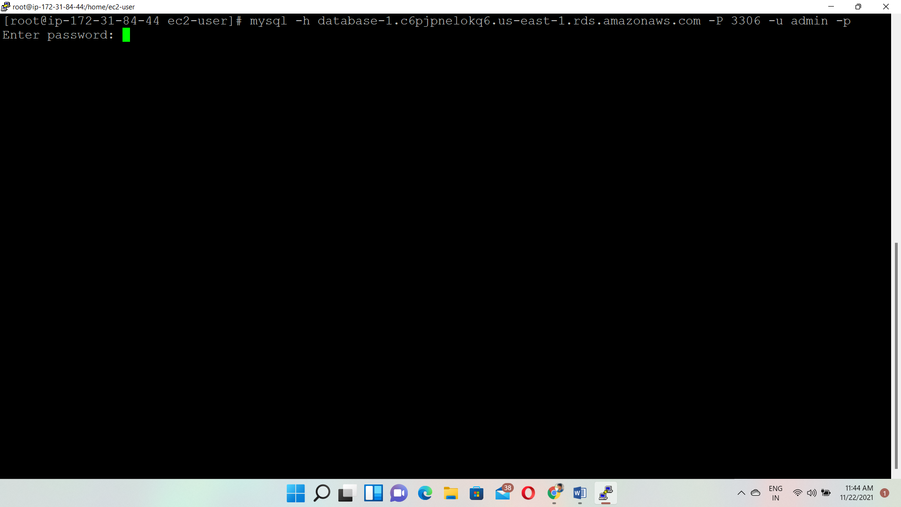

Successfully Connected the MySQL Database from RHEL 8 instance

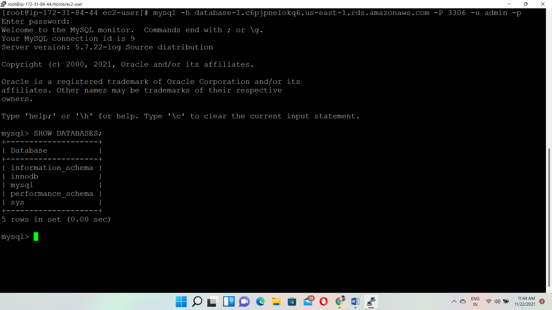

Create 2 Databases DB1, DB2

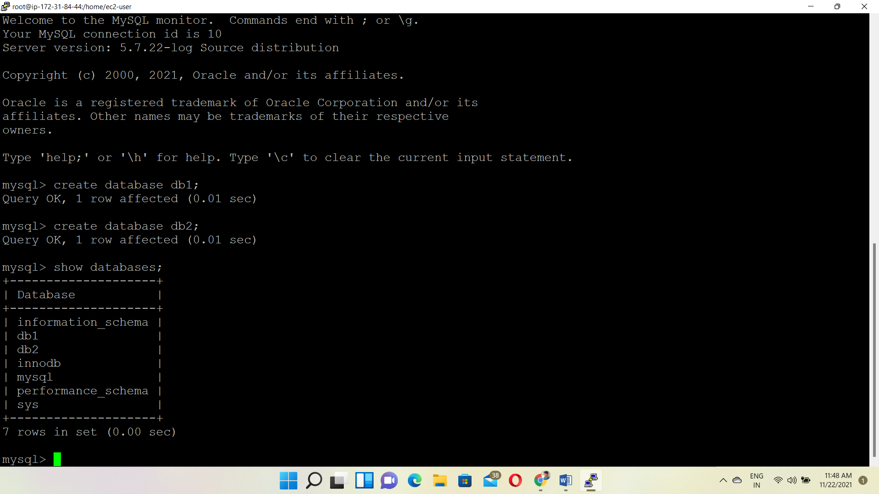

Take Snapshot For Backup purpose

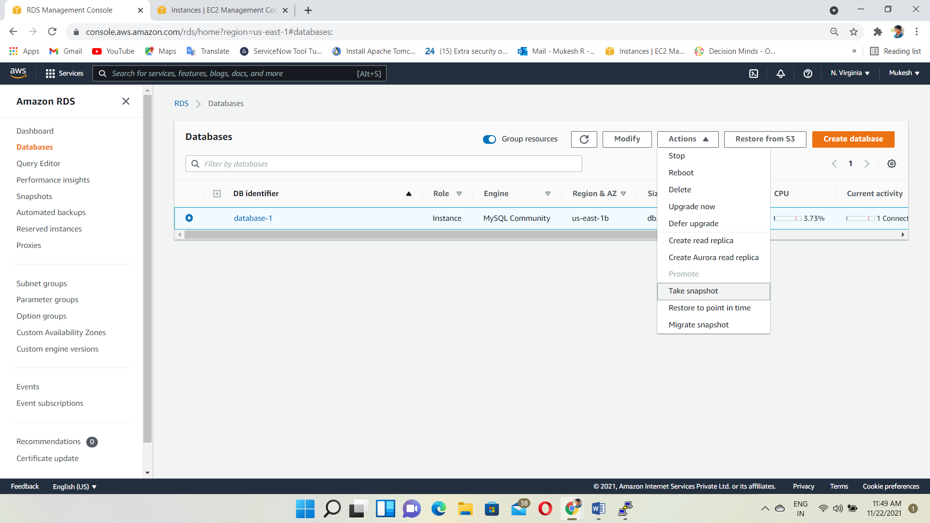

Give the Snapshot Name & Taken the snapshot

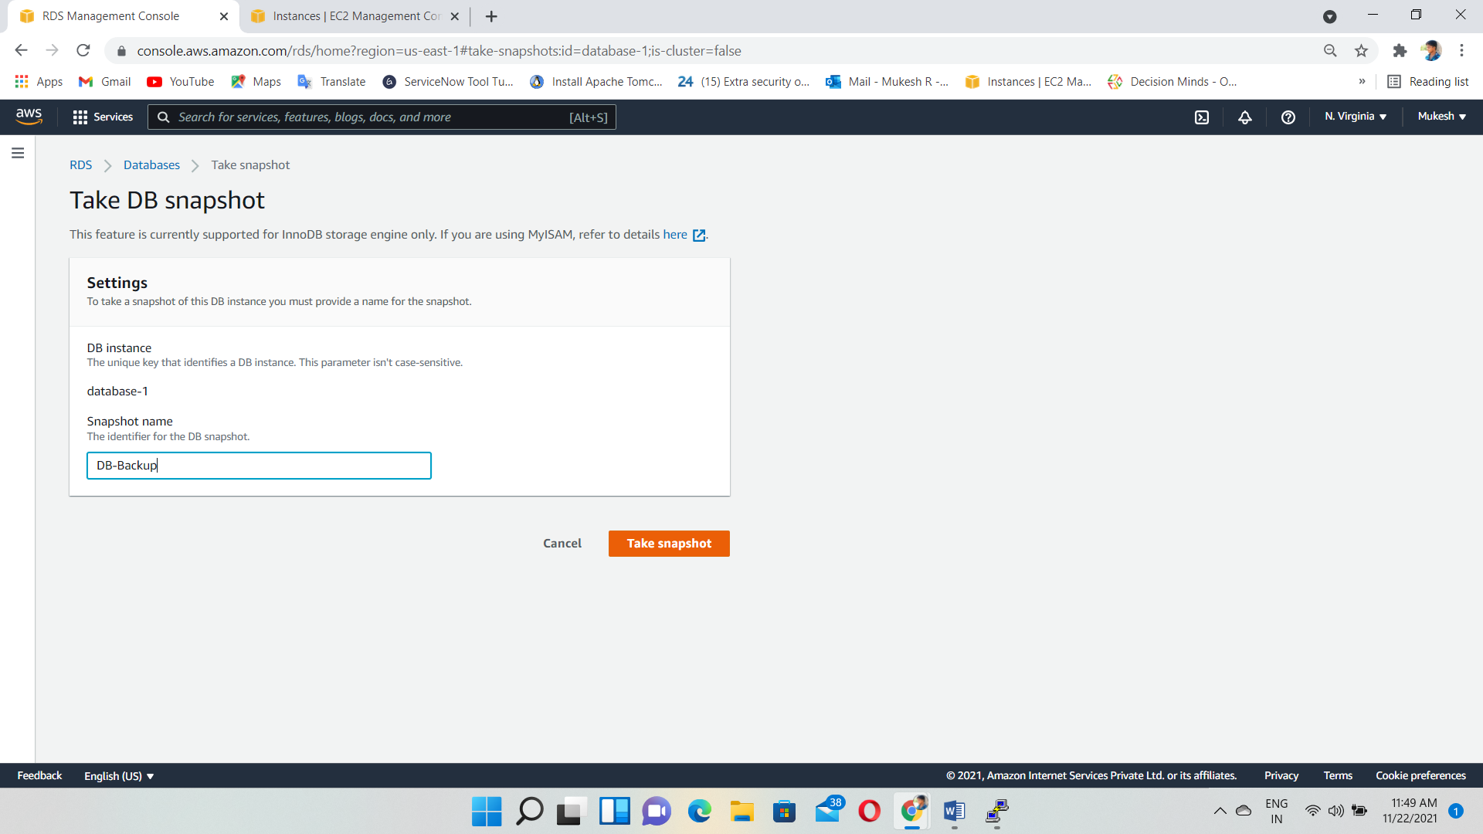

And then, delete the DB instance

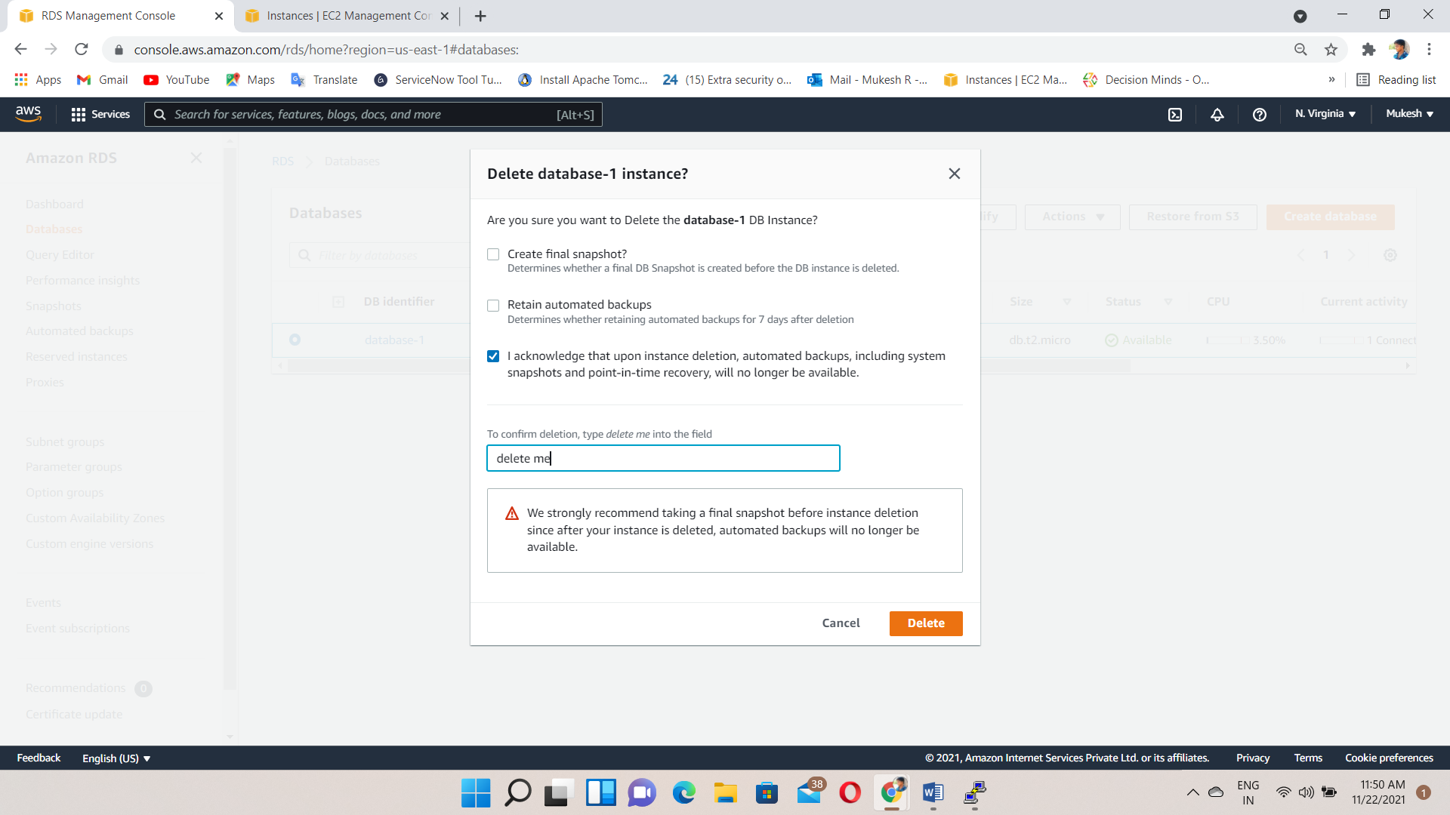

Deleted

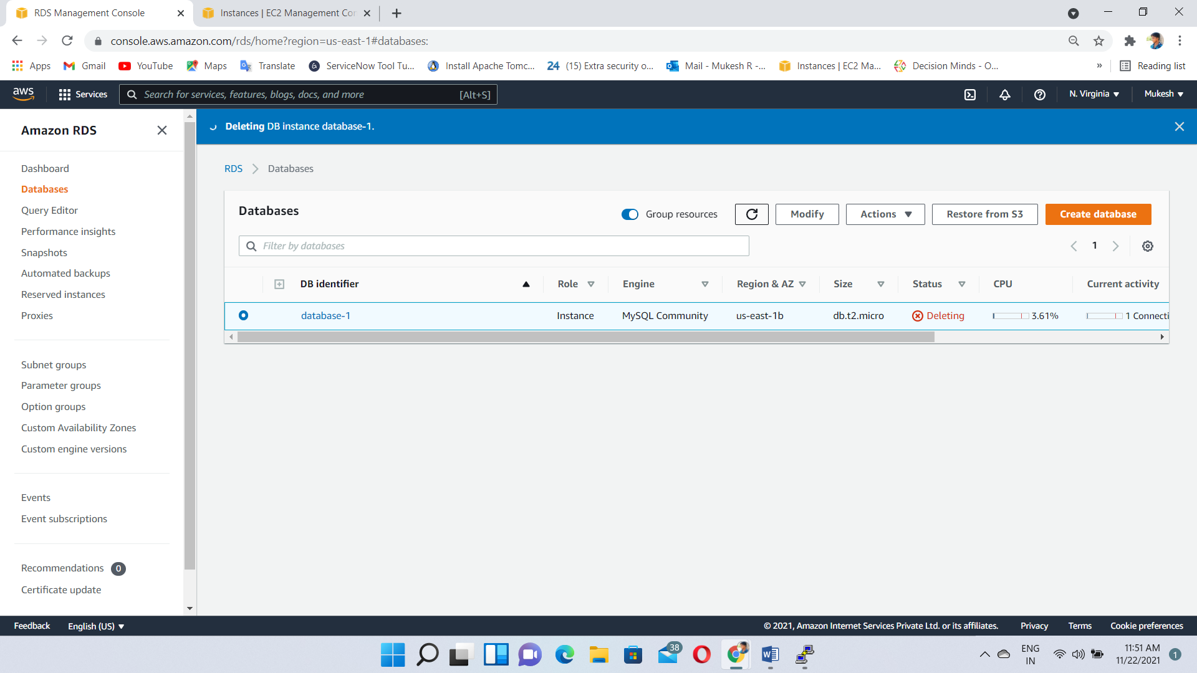

Go to the Snapshot & click action & restore the snapshot

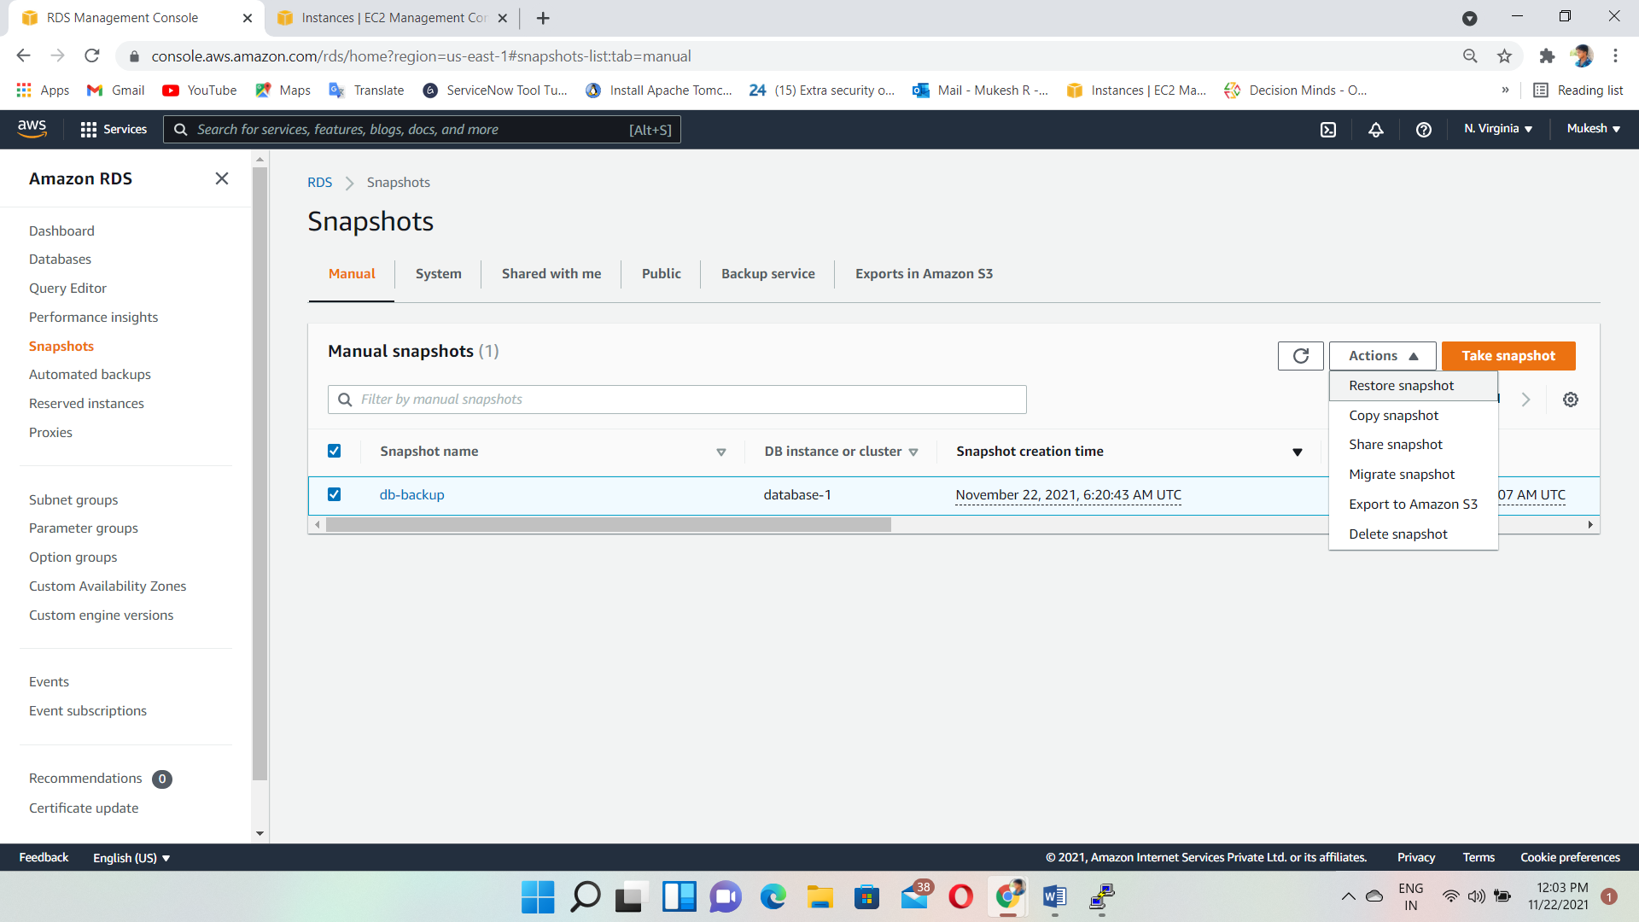

Giving Database details

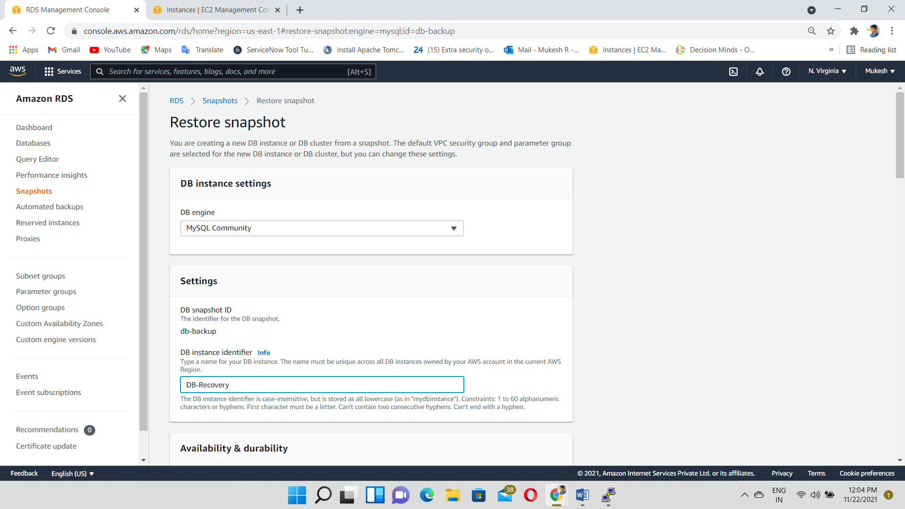

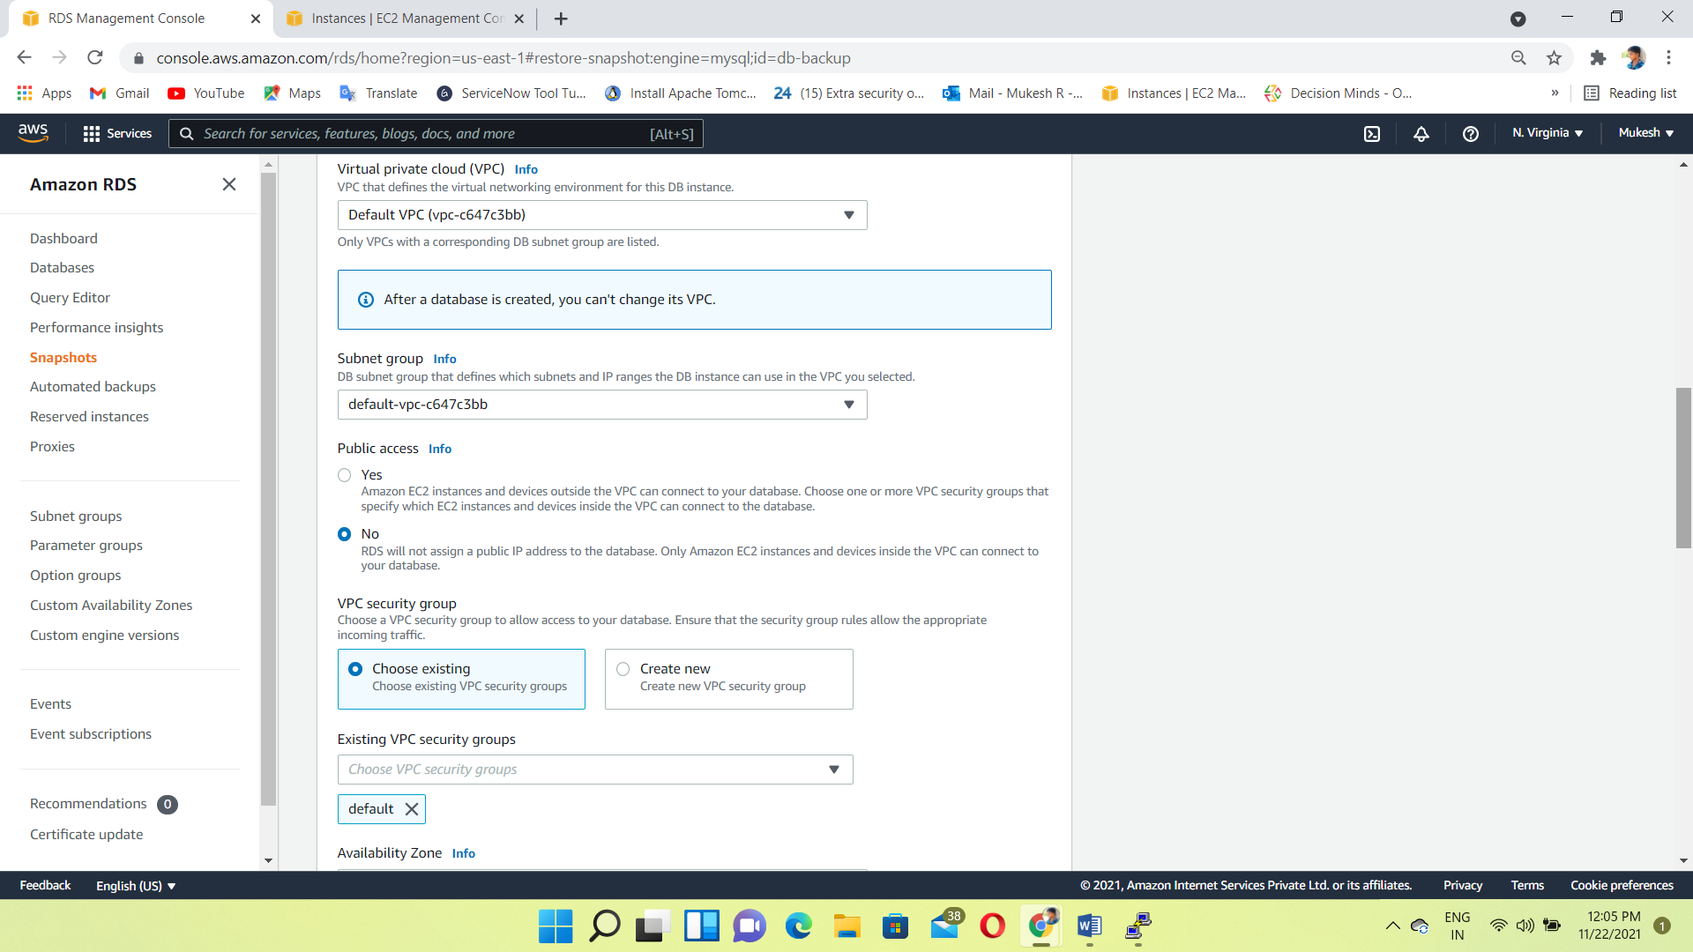

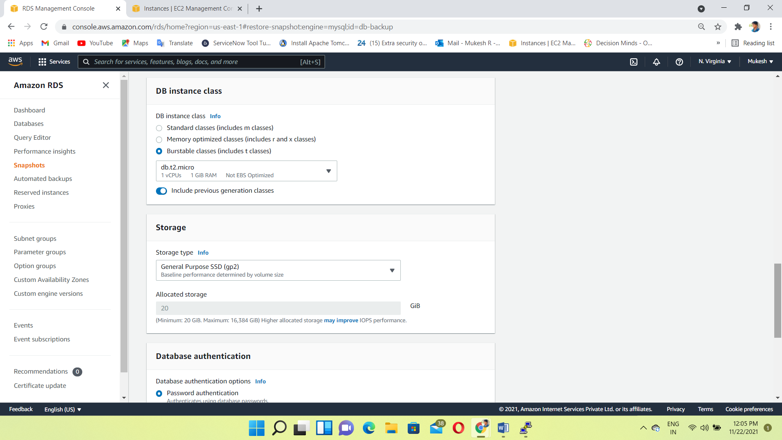

Restore the Database

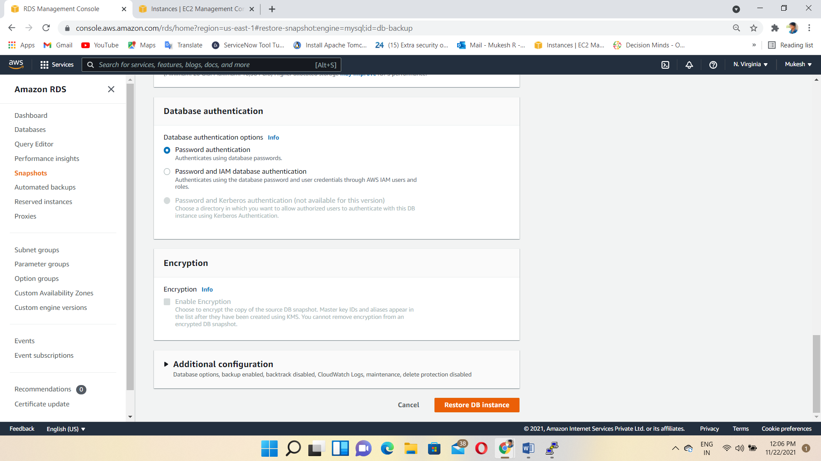

Backup instance created

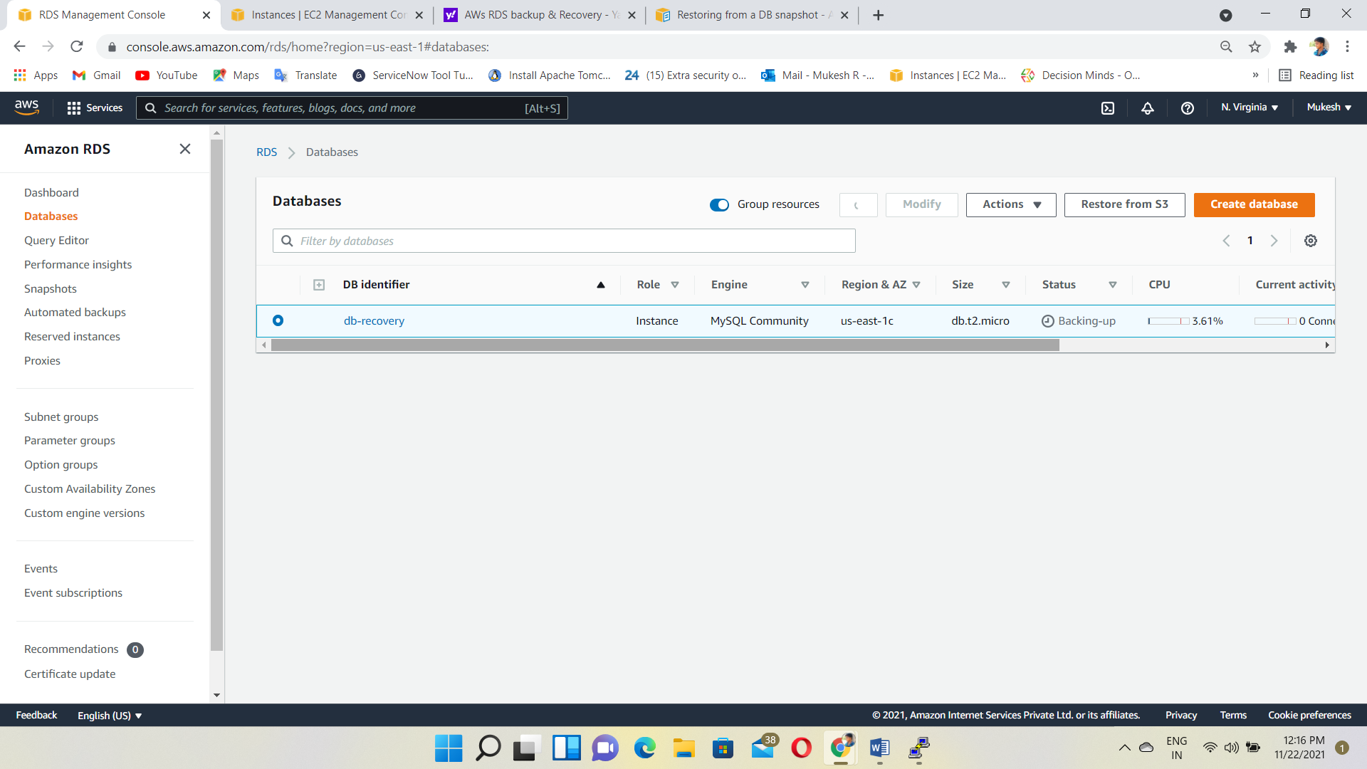

Copy the Database Endpoint

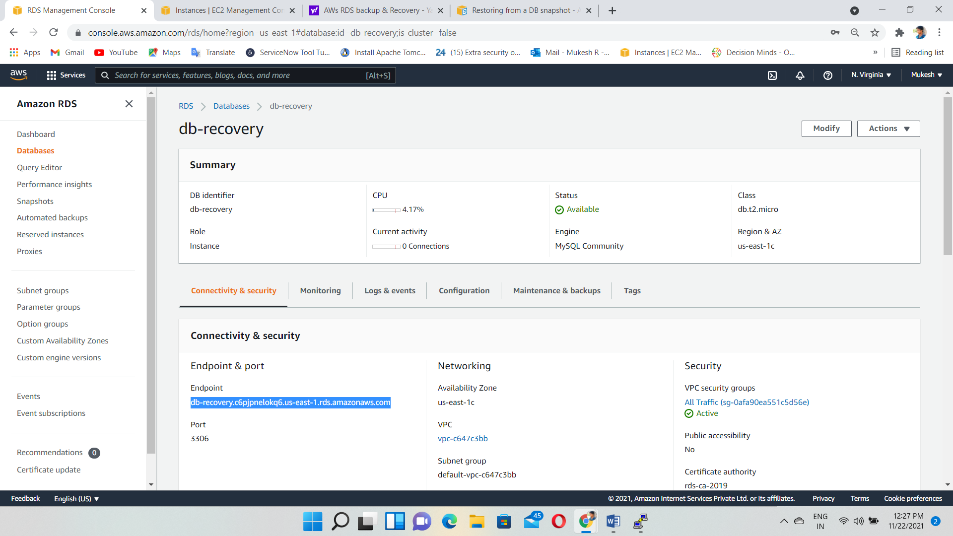

**OUTPUT:**

Again, we connected the MySQL using that endpoint

Finally, we recover the Databases DB1, DB2.

